

Job information pack
Head of Scotland

Thank you for your interest in Pancreatic Cancer UK |  | 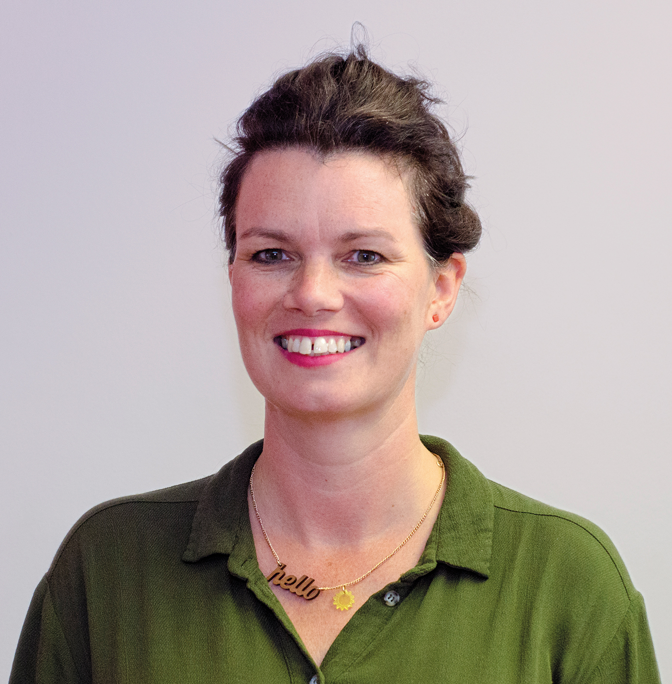

I am delighted that you are interested in working with us. If you decide to apply for a role at Pancreatic Cancer UK, and go on to join us, I know you won’t be disappointed.

I joined the charity as CEO eighteen months ago, and since then I have been absolutely inspired by the incredible team we have here at Pancreatic Cancer UK, by our amazing supporters, and by the sheer courage of those affected by pancreatic cancer. Almost without exception, just about everyone who comes to join our team finds they too are similarly inspired and determined to make a difference. If you want to be part of generating real, positive change, then Pancreatic Cancer UK is the place to be - and helping make that change never more important:

Pancreatic cancer is the toughest cancer to diagnosis, treat and survive
Pancreatic cancer is the deadliest common cancer. This dreadful disease is often diagnosed late, and progresses quickly – heartbreakingly, 3 in 4 people won’t survive a year.

Yet for too long, the disease has been sidelined, with research into the disease historically underfunded. Over the last decade, research into pancreatic cancer has received less than 1% of the cancer research budget. As shockingly, only 8% of people with pancreatic cancer are offered life-saving surgery – either because they’re not diagnosed until too late, or are not offered treatment fast enough - something Pancreatic Cancer UK recently highlighted in our ground-breaking Demand Faster Treatment campaign.

The reality is that Pancreatic cancer treatment can’t wait. We need change, fast.

But thanks to our staff and our amazing supporters, we are making a stand and demanding;

- More money for more research.
- More focus on early diagnosis
- Better, faster treatment and care
As importantly, Pancreatic Cancer UK provides expert advice and support directly to those affected by the disease, and we support the pancreatic cancer community with a strong, constructive voice.
We want to make sure that everyone affected by the disease gets all the help they need, and our overall aim is to double survival rates and transform the future for everyone with pancreatic cancer.

But we can’t do this alone - we can only succeed if we take it on together. You could be a key part of our success.

Our work in Scotland is a central part of our activity to take on pancreatic cancer. Researchers in Scotland are leading the way in developing new exciting approaches to tackle pancreatic cancer, particularly through the Precision Panc programme based in Glasgow and we are delighted to be the patient engagement partner for this initiative. We also chose Scotland as the location for our first ever Future Leader’s Academy, which we fund at the Beatson Centre, to further drive our ambition to attract the next generation of bright minds into the pancreatic cancer field. As a charity we have been working hard to push pancreatic cancer up the political agenda in Scotland through the Cross party group, events and debates in the Scottish Parliament, working with some very dedicated supporters.

But we have much more to do. Particularly to make sure that everyone diagnosed in Scotland knows about the services we provide and has access to our face to face services to reduce isolation and improve quality of life.

Your reward will be to see more people with pancreatic cancer have the chance to live longer, better lives. What’s more, you’ll be joining an incredible team and a great place to work:
- We’re a small charity, so you’ll feel part of a team, not a machine. We celebrate all our achievements together, we make sure new starters get a great welcome, and we never forget we are a community where everyone has value.
- We’re passionate about our cause, and are in a strong position to make a difference.
- We make sure you can give your best – we’ll invest in your learning and development, we’ll value your skills and experience, and we’ll give you the chance to shine.
- We have a great team of passionate and determined staff and supporters, with strong partnerships with patients, families, fundraisers, medical professionals, researchers and policy makers.
- We encourage a healthy work-life balance and are always happy to discuss flexibility in light of the needs of the role. We have high levels of job satisfaction and a collaborative and innovative culture – and I know everyone here would join me in being proud to work here.
So, if you feel excited and inspired by the prospect of joining us to take forward our challenging agenda in Scotland, we would love to hear from you. Please find enclosed further information about the Charity, the disease and this position, and do look at our website and read the job description and person specification to see how you would meet with our needs.
We hope to hear from you soon.

With best wishes,

Diana Jupp
Chief Executive

Job Description
Head of Scotland

Background

This is an exciting time to join a fast growing charity with big ambition as we seek to grow our profile and expand our activities in Scotland. We fund research into pancreatic cancer, provide services for those diagnosed and their families and campaign to achieve change in outcomes from this devastating disease.

The charity has always been active across the UK but has been expanding its activities in Scotland, providing a significant level of research investment, growing our influencing activity to specifically call for a review of pancreatic cancer services and starting to roll out our face to face services. Over the last two years the charity has had a consultant and Interim Head working with the charity to start to shape our priorities for work in the nation but this will be the charity’s first permanent role in Scotland. The role will sit within the Operations Directorate and have a key focus on establishing the charity’s presence and profile in Scotland working to engage with key stakeholders to increase our service presence, influence to improve treatment and care, increase research collaboration and increase our fundraising activity. The post holder will need to work closely with teams across the charity.

You will play a crucial role in ensuring our work is appropriately tailored to meet the needs of people affected by pancreatic cancer in Scotland and our wider stakeholders and to ensure we are responding to key concerns or opportunities around pancreatic cancer within the nation. You will also help us build relationships with key health and policy stakeholders in Northern Ireland, working with our postholder there. This is an exciting time to join the charity and help shape our work as we start to develop our next organisational strategy.

PURPOSE

The Head of Scotland will be a key member of the Operations Directorate and will be responsible for the successful growth of Pancreatic Cancer UK’s presence and activities in Scotland.
The role will report to the Director of Operations but will need to work closely with the Director of Fundraising and Communications and other Heads across the Charity. The post holder will co-produce strategic plans for services, policy and campaigning, engagement and fundraising activity in Scotland working with the relevant function Heads and lead on the implementation of these plans.

The successful candidate will be skilled in developing and maintaining strong working relationships with key stakeholders from across the pancreatic cancer community - including supporters, health professionals, policy makers, MSPs, researchers, funders, major donors and other charities – to enable us to meet our strategic objectives.

The postholder will also be responsible for helping us build and maintain relationships with key healthcare charity and Government stakeholders in Northern Ireland. We have a well established Community Co-ordinator post in this nation, working to raise awareness of our charity’s services and other work. However this postholder would benefit with greater senior level support in maintaining these crucial relationships.
The post holder will need to ensure excellent internal communication and effective co-working is maintained with the London Office. They will receive support for their activity from teams across the charity and the benefit of their specialist expertise. The charity will review the capacity needed in Scotland in the future as activity in the nation develops. The initial priority for the role will be to co-produce a two year plan for services, policy and campaigning, fundraising and engagement activity in Scotland with the relevant Heads of function plans.

MAIN RESPONSIBILITIES

NB There will be a phased delivery of aspects of the role as our presence in Scotland develops.

Stakeholder engagement and organisational profile

- Develop and maintain effective relationships and partnerships with health professionals and other charity partners in the nation to raise the profile of the charity’s services and training and maximise use of our existing and new face-to-face and national specialist support services as well as our study days.
- Identify, develop, cultivate and own effective relationships with key Government and NHS influencers and decision-makers in Scotland, as well as partner organisations and charities to raise the profile of the disease, influence their priorities and delivery, gain intelligence and develop strategic alliances.
- To achieve membership of and represent the charity at appropriate cancer, health or NHS policy and public affairs forums to maximise the impact of our influencing and campaigning work.
- Proactively brief external stakeholders on the needs of people affected by pancreatic cancer and improvements required in Scotland, based on evidence and proposed solutions developed by or in association with the wider Operations Directorate, identifying and maximising any opportunities for Pancreatic Cancer UK.
- Contribute to the successful implementation of the Involvement strategy in Scotland – growing, building and maintaining strong working relationships with our supporters in Scotland and ensuring they can help shape and contribute to our activity.
- Work with the Senior Campaigns and Involvement Manager to grow, manage and develop the role of supporters involved in policy and campaigning activity in Scotland.
- Support the development and maintenance of relationships with major donors and key community fundraisers.
- Work with the Head of Research to strengthen our relationships and partnership working with the research community in Scotland in particularly with the Future Leaders Academy and Precision Panc Team.
- Support the development and maintenance of key health professionals, charity partners and Government relationships in Northern Ireland to support the work of the Community Co-ordinator based in the nation, supporting our influencing activities to drive care improvement.

Supporting Service delivery

- With the Head of Services and Service Development Manager co-produce operational plans for the development and delivery of face-to-face services in Scotland, highlighting service needs and identifying opportunities for expansion, including partnerships, to successfully deliver our objective to extend our reach.
- Work with NHS providers to facilitate the charity having regular information stands within NHS settings and at appropriate conferences/training events.
- Support the Senior Service Development Manager and Events Manager to develop key relationships in order to develop appropriate training activities/events for health professionals in Scotland.
- Work with the Senior Community and Involvement Manager to recruit, train and manage a team of information volunteers in Scotland as well as other volunteer roles as they are introduced and are appropriate to priorities in the nation.
Supporting Influencing Activity

- Provide the Policy and Campaigns team with insight and intelligence on health policy and NHS service development and the political climate that will influence policy and campaigns objectives and plans.
- Contribute to plans being developed by the Head of Policy and Campaigns for policy and campaigns activity in Scotland to raise the profile of the disease and drive improvements in treatment and care.
- Comment on policy briefings/reports, positions and consultation responses produced by the policy and campaigns team to ensure they are relevant to a Scottish audience.

External marketing, communications and fundraising

- Work with the Director of Fundraising and Communications Head of Strategic Communications, Senior Media Manager and Head of Services to co-produce the marketing, communications and supporter engagement strategies for developing our profile and recognition in Scotland.
- Support the work of the Director of Fundraising and Communications and Heads of Fundraising, to seek funding for existing and future activities in Scotland through identifying opportunities and co-producing plans for fundraising in Scotland
- Proactively represent Pancreatic Cancer UK to the general public, media and at fundraising events, act as a media spokesperson, ensure social media presence and give talks and presentations to appropriate audiences/conferences that focus on activity in Scotland.
- Support the delivery of community and high profile fundraising events and activities in Scotland.

Corporate management

- Ensure that financial management of the Scotland budget is carried out in line with Pancreatic Cancer UK’s procedures, including budget preparation, monitoring, reforecasting, banking, and the authorisation of invoices and expenses.
- Secure a registered Scotland address for the charity.
- Develop, implement and monitor the business plans for Scotland activity working with Head’s across the charity.
- Ensure the consistent and efficient use of our CRM database to record activity and impact in Scotland.
- Ensure all work in Scotland is GDPR-compliant.
- Take lead responsibility for progressing agreed projects as required.

General

- Proactively contribute to team meetings and other organisational activities, including Heads meetings.
- Ensure effective communication and cross working with all departments across Pancreatic Cancer UK
- Prepare and present written reports and information as required
- Ensure the Senior Management Team and relevant Heads are kept informed of all key activities and developments in Scotland.
- Be proactive in developing the role and activities of the charity in Scotland.
- Abide by organisational policies and the charity’s values
- Assist with other general duties as required.
- Ability to travel regularly across Scotland and drive own vehicle (and occasional UK wide travel), including occasional overnight stays, and to attend evening/weekend meetings as required.
- Travel to London to attend organisational meetings as required.

Person Specification

Criteria | Essential (E)  Desirable (D) | Application (A)  Interview (I)  Test (T)
Qualifications
Degree or equivalent professional qualification, which demonstrates academic achievement and competence. | E | A
Knowledge and understanding
Knowledge of strategies for raising the profile of an organisation and cause. | E | A,I
Good understanding of national and local health services, health policy, and the key stakeholders and organisations in the health service field in Scotland. | E | A,I
Knowledge of the Scottish parliament and key parliamentary processes. | D | A
Knowledge and understanding of good practice processes and procedures for service delivery including safeguarding policy and process. | D | A
Experience
Extensive experience of developing and maintaining effective relationships with key stakeholders and influencing them to achieve desired outcomes. | E | A,I
Representing an organisation externally on charity or equivalent coalitions or government working groups. | E | A,I
Working with people affected by a health condition, charity supporters or members of the public who are interested in an issue or affected by a cause and using different methods to engage them in organisational activities. | E | A,I
Working within a UK-wide organisation and working with different teams to co-produce and deliver plans. | E | A
Operational planning and budgeting. | E | A
Managing volunteers and/or staff | E | A,I
Track record of developing and delivering services, ideally in a health setting. | D | A,I
Skills and competencies
Advanced user of Microsoft Office (Word, Excel, Powerpoint, Outlook) | E | A
Excellent written communication skills for a variety of formats including presentations, reports, web copy, newsletter and social media. | E | A,T
Comfortable with and committed to pro-active networking at a range of levels and gaining credibility | E | A,I
Ability to represent the charity with key fundraising contacts. | E | A,I
Strong project management skills, including managing risks, achieving set objectives and evaluating success. | E | A,I
Ability to review and input to written policy and campaigning materials including briefings and consultation responses. | D | A
Personal qualities
Commitment to our vision, mission and values: Determined, Compassionate, Pioneering, With Integrity, and to learning and development | E | I
Other requirements
Right to work in the UK at the time of application | E | I
Ability to travel regularly across Scotland including driving a personal vehicle (and occasional UK-wide travel), including occasional overnight stays, and to attend evening or weekend meetings as required, A current driving licence is essential. | E | A,I

Criminal record checks
We are entitled to undertake enhanced criminal record checks on Services team staff who work directly with patients and their carers. We will not ask applicants in these roles to disclose until they have been offered a role with us. We abide by the Disclosure Scotland Code of Practice where candidates are based in Scotland.

A criminal record check is required for this role at enhanced level for working with adults.
A check of the adults barred list is not required.

Please email jobs@pancreaticcancer.org.uk if you would like to see a copy of our policy on the recruitment of ex-offenders.

Main terms of employment

Reporting to: Director of Operations

Salary: £47000-£52000 per annum

PCUK Band G: Head of function

Location: Edinburgh or Glasgow. Desk space to be secured by postholder in Edinburgh or Glasgow with a partner organisation. Some home working will be considered.

Hours: Full time – 35 hours per week, Monday to Friday. May be willing to discuss flexible working.

Tenure: Permanent

Holidays: 25 days per year, plus bank holidays. The holiday year runs from 1 April to 31 March.

Pension: We will automatically enrol eligible employees in our Royal London pension scheme on their start date. PCUK will contribute 4% of gross salary; employees are required to contribute 3% of gross salary. Employees can opt out of the scheme at any time.

Benefits: We offer travel loans for the purchase of an annual season ticket, death in service benefit and paid compassionate leave. All employees have access to our employee assistance programme offering a free, confidential helpline on work and personal matters.

How to apply

- Please submit a CV with a Supporting Statement to donna@awsrecruitment.co.uk by the closing date and time.

- Please complete the Supporting Statement Template we have provided, setting out how you meet the essential criteria marked A for application. If you meet the desirable criteria, you can refer to those too. For each criterion, you need to provide actual examples from your work experience. Please note that you are very unlikely to be shortlisted unless you prepare this Supporting Statement – a generic covering letter is unlikely to provide the information we need.
- The closing date for submitting applications is Monday, 1 July 2019 at 9am.
- Interviews will take place in London on Wednesday, 10 July 2019. Reasonable travel expenses will be reimbursed on production of receipts, and with prior approval.

- If we invite you to interview, you will need to bring an original document to prove your right to work in the UK and your current driving licence. We will provide details will be provided in the invitation.

June 2019

