Role Profile – Planned Giving Fundraising Officer
Reports To: Head of Fundraising
Role Purpose:
In this role you will lead effective marketing programmes and campaigns for donor growth and acquisition. You will play a key part in accelerating revenue growth in line with our strategy to achieve transformational fundraising in 10 years.
You will lead in the development of an integrated Individual Giving strategy that recruits, retains, and reactivates supporters, maximising their lifetime value and deliver a best in class supporter experience, based on deep insights and data.
You will manage Individual Giving campaigns and work with the Supporter Care Fundraiser to ensure high quality supporter care including responsive and prompt stewardship.
All roles within Sight Scotland and Sight Scotland Veterans are expected to work to our values and Our Ways of Working framework:
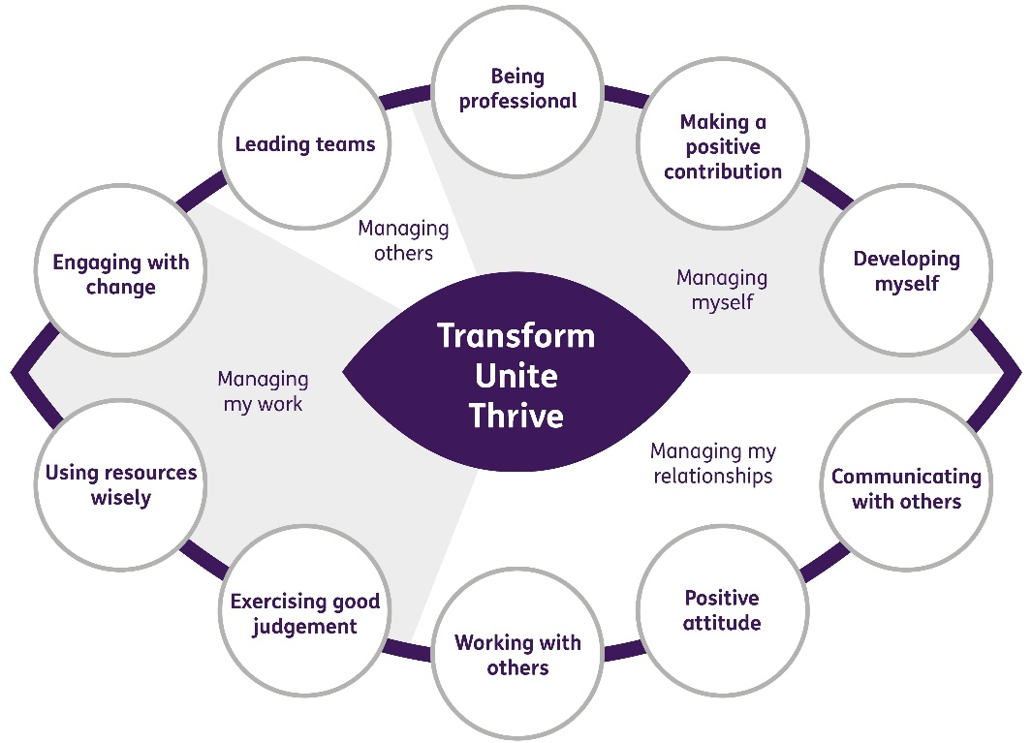

Our Ways of Working - Managing my Work
The main responsibilities and accountabilities of this role are:
Individual Giving
- Work with the Head of Fundraising to create a five-year rolling plan for Individual Giving
- Design, deliver and continually improve multi-channel stewardship journeys for new and existing supporters
- Manage Sight Scotland’s Individual Giving programme, including planning, liaising with external agencies, data and execution to recruit and develop committed givers and cash donors, using a variety of channels, to build the database as a key way of securing unrestricted income
- Manage all elements of regular givers, including the reactivation process and communication, upgrades, and the communications and journeys for all regular givers
- Manage Gift Aid ensuring income through this process is maximised in line with regulations
- Explore and develop possibility of a lottery as a form of individual giving

Reporting and analysing and data
- Lead the management of the Raiser’s Edge NXT database to ensure it is effectively and efficiently being used for stewardship, donor care, reporting and analysis
- Manage data segmentation and profiling for all campaigns and appeals
- Use Raiser’s Edge NXT and other data management and research tools to assist in data mining and prospect identification
- Produce in depth analysis of campaigns and appeals, producing income projections and lifetime value modelling and forecasts, ensuring the development of a long- term sustainable income stream
- Work with the Head of Fundraising to report on the identified KPI’s
- Use insight from previous results to focus on journeys that increase average values and long-term support
- Contribute to the Board report three times a year
- Work together with the Relationship and Supporter Care Fundraiser to ensure donations are correctly allocated and appropriately thanked.
- Responsibility for overseeing GDPR compliance
- Liaise with finance to ensure timely and accurate processing of direct debits and fundraising related finance.

Campaigns
- Work with colleagues across the department to identify and develop case studies for Individual Giving campaigns and donor care updates
- Work with relevant colleagues and agencies to create engaging copy and design, balancing the need to communicate en-masse with personalised and meaningful content
- Work with colleagues to drive income through integrated campaigns through digital means, website and other marketing campaigns
- Manage the creative process for developing campaigns
- Produce and keep updated all donor thank you copy and donor communications

Other
- Adhere to the highest standards of fundraising practice
- Ensure that all activities comply fully with the relevant Data Protection obligations and any other legislation.
- Work with colleagues to use data segmentation to develop and adapt supporter journeys in order to maximise retention and optimise lifetime value.
- Build relationships with internal stakeholders and help foster a fundraising culture
- Ensure relevant records on the database are kept up to date and accurate
- Keep up to date with changes in legislation, tax implications for charitable giving and Institute of Fundraising policies

Contribute to the work of the Marketing and Communications department
- Support cross team projects and events
- Work effectively and collaboratively with colleagues across the department
- Represent the organisation at conferences, exhibition stands and events

Our Ways of Working – Managing Myself and Managing my Relationships

To do this role, you will have:
Professional experience of:
- Fundraising from individual donors
- Developing and managing donor journeys and stewardship
- Using Raiser’s Edge or similar
- Working with agencies and external suppliers

Knowledge of:
- The charity sector
- Budget planning and financial modelling

Skills:
- High level of database management and analysis skills, including the ability to segment data appropriately to create targeted campaigns
- Excellent writing skills, with good grammar and a persuasive writing style
- Strong relationship building skills
- Effective planning and organisation skills
Other:
- Ability to work flexibly including evenings and at weekends

It is desirable that you will have:
- Membership of the Institute of Fundraising
- Qualification in fundraising

On a day to day basis you will work with different people and teams, these could be:
- Heads of Service
- Directors
- Senior Leadership and Management Teams
- Service Users
- Families
- Colleagues
- Other Sight Scotland services
- Senior Staff

Requirements of this role are:
- You are a member of the PVG scheme (paid for by Sight Scotland)
- You will have a 6 month probation period
- That you participate in all staff training and development and maintain your own professional development
- You will wear the appropriate PPE in accordance with current guidance for the role.
- You will follow Sight Scotland’s guidance, policies and procedures relating to your own health and safety and that of colleagues and service users at all times.
- You will uphold the principles of Sight Scotland’s Dignity at Work and Equal Opportunities policies at all times, working in a way which supports an inclusive work environment that is respectful of differences.

What we can offer you:
- Generous pension scheme
- Discounts for Carers
- Access to learning and development opportunities
- Employee Perks through the Employee Assistance Programme
- Cycle to Work scheme
- And many more, please visit our website for more information

This job profile is not exhaustive. The duties of the post holder may be reviewed from time to time and the employee may be called upon to work in other locations within Sight Scotland or Sight Scotland Veterans.

